Spring MVC
- What is Spring MVC?
It is a spring framework which is used for building web applications. Spring MVC follows Model-View-Controller Design Pattern.
- Request Processing Workflow in Spring MVC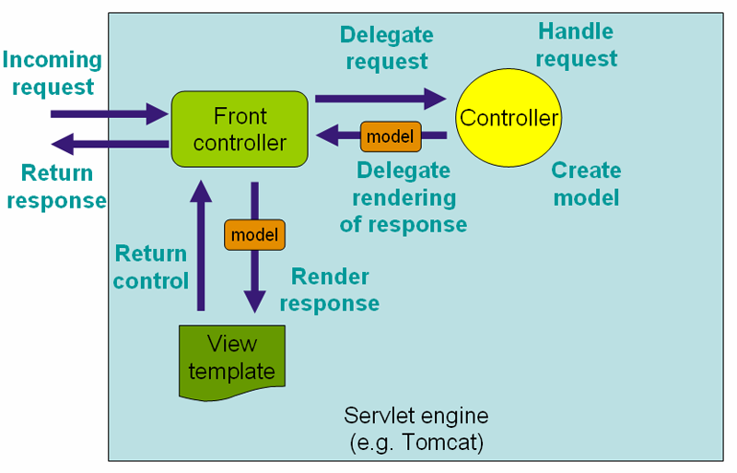
Key Components:
- Front Controller (DispatcherServlet): This is the central entry point for all requests in a Spring MVC application. Think of it as the "traffic cop" that directs incoming requests to the right place. In Spring, this is specifically the DispatcherServlet.
- Controller: This is where your application's logic for handling specific requests resides. It processes the request, interacts with your business services, and prepares data.
- Model: A simple container (like a Map or a plain Java object) that holds the data that needs to be displayed on the web page. The Controller creates this data.
- View template: This is typically a file (like a JSP, Thymeleaf, or FreeMarker template) that defines how the data from the Model should be presented to the user (e.g., as an HTML page).
- Servlet Engine (e.g., Tomcat): The application server that hosts and runs your Spring Web MVC application.
Step-by-Step Workflow:
- Incoming Request:
- What happens: A user's web browser (or another client) sends an HTTP request (e.g., typing a URL, clicking a link, submitting a form) to your web application running on the server.
- In detail: This is the starting point of the entire process. The request could be a GET request to retrieve data (like /products/list) or a POST request to send data (like submitting a login form). The request first reaches the Servlet Engine (e.g., Apache Tomcat), which is the server running your web application.
- Front Controller (DispatcherServlet) Receives Request:
- What happens: The Servlet Engine, based on your application's configuration (usually web.xml or Java configuration), identifies that this incoming request should be handled by the Front Controller (which is Spring's DispatcherServlet).
- In detail: The DispatcherServlet is designed to be the single point of entry for all web requests in your Spring MVC application. It's not responsible for actually processing the request's business logic, but rather for delegating that responsibility to other components.
- Delegate Request to Controller:
- What happens: The DispatcherServlet looks at the incoming request's URL and other details to figure out which specific Controller method is configured to handle this particular request.
- In detail: Spring uses "Handler Mappings" (often based on annotations like @RequestMapping on your Controller methods) to match the incoming URL to the correct Controller method. Once a match is found, the DispatcherServlet invokes that specific Controller method, passing relevant request data to it.
- Controller Handles Request and Creates Model:
- What happens: The chosen Controller method executes its logic to process the request. It performs necessary operations and prepares any data that needs to be displayed to the user. This data is then put into a Model object.
- In detail: This is where your application's business logic for that specific request resides. For example, if it's a request for a product list, the Controller might call a ProductService to fetch product data from a database. If it's a form submission, it might validate the input and save it. The result of this processing – the data you want to show on the web page (e.g., a list of products, a user's details, a confirmation message) – is packaged into a Model. The Controller returns this Model, often along with the logical name of the View to the DispatcherServlet.
- Model Returned to Front Controller:
- What happens: The Controller returns the Model (containing the data) and the logical name of the View (e.g., "productsList", "welcomePage") back to the DispatcherServlet.
- In detail: The DispatcherServlet now has both the data that needs to be displayed and an indication of which type of page (View) should be used to display it.
- Delegate Rendering of Response to View Template:
- What happens: The DispatcherServlet needs to find the actual physical location of the View template based on the logical view name provided by the Controller. Once found, it delegates the task of generating the final response to this View template.
- In detail: The DispatcherServlet uses "View Resolvers" (e.g., InternalResourceViewResolver for JSPs, ThymeleafViewResolver for Thymeleaf) to translate the logical view name (like "productsList") into a concrete path (like /WEB-INF/views/productsList.jsp). After resolving the view, the DispatcherServlet passes the Model data to the View template.
- View Template Renders Response:
- What happens: The View template takes the data from the Model and combines it with its own structure (e.g., HTML, CSS, JavaScript) to produce the final output that will be sent to the user.
- In detail: For instance, if it's a JSP, it will use JSTL tags or Expression Language (EL) to inject the Model data into the HTML structure. If it's a Thymeleaf template, it uses Thymeleaf's specific syntax. This step is purely about presentation; it transforms the raw data into a human-readable (or machine-readable, like JSON) format.
- Return Control (and Rendered Response) to Front Controller:
- What happens: Once the View template has finished generating the complete response (e.g., a full HTML page), it hands this rendered content back to the DispatcherServlet.
- In detail: This signifies that the View's job is complete, and the DispatcherServlet now has the final, ready-to-send output.
- Front Controller Returns Response:
- What happens: The DispatcherServlet sends the final, fully rendered response back to the user's browser.
- In detail: This is the HTTP response that the client receives. The browser then renders this response (e.g., displays the HTML page) to the user.
- What is the use of Model & ModelMap in Spring MVC
In Spring MVC, Model and ModelMap are both used to carry data from the controller to the view (JSP file) . In JSP file <c:out value= “${name of variable set in controller}”></c:out>
- What is modelAttribute in Spring MVC and how to use it?
- What is DispatcherServlet.
It is the front controller which acts as single entry point for requests and delegates the requests to the Controllers in Spring MVC.
- What is ViewResolver?
It is responsible for mapping logical view (which is returned by controller) with actual view (the actual jsp file) and returns the actual view back to dispatcher servlet
- How to handle exceptions in spring MVC?
- Using HTTP Status Code
- Controller Based Exception Handler using @ExceptionHandler
- Global Exception Handling using @ExceptionHandler & @ControllerAdvice.

